WEEK – 7
React Mandatory Hands On
9)CRICKETAPP
IndianPlayers.js
import React from 'react';
function IndianPlayers() {
const IndianTeam = ["Sachin1", "Dhoni2", "Virat3", "Rohit4", "Yuvaraj5", "Raina6"];
const OddPlayers = ([first,, third,, fifth]) => (
<div>
<h1>Odd Players</h1>
<ul>
<li>First : {first}</li>
<li>Third : {third}</li>
<li>Fifth : {fifth}</li>
</ul>
</div>
);

const EvenPlayers = ([, second,, fourth,, sixth]) => (
<div>
<h1>Even Players</h1>
<ul>
<li>Second : {second}</li>
<li>Fourth : {fourth}</li>
<li>Sixth : {sixth}</li>
</ul>
</div>
);

const T20players = [
"Mr. First Player",
"Mr. Second Player",
"Mr. Third Player"
];
const RanjiTrophyPlayers = [
"Mr. Fourth Player",
"Mr. Fifth Player",
"Mr. Sixth Player"
];
const IndianPlayers = [...T20players, ...RanjiTrophyPlayers];
return (
<>
{OddPlayers(IndianTeam)}
<hr />
{EvenPlayers(IndianTeam)}
<hr />
<div>
<h1>List of Indian Players Merged:</h1>
<ul>
{IndianPlayers.map((player, index) => (
<li key={index}>{player}</li>
))}
</ul>
</div>
</>
);
}
export default IndianPlayers;

ListofPlayers.js
import React from 'react';
function ListofPlayers({ players }) {
return (
<ul>
{players.map((player, index) => (
<li key={index}>
{player.name} {player.score}
</li>
))}
</ul>
);
}
export default ListofPlayers;

Scorebelow70.js
import React from 'react';
function Scorebelow70({ players }) {
const filtered = players.filter(player => player.score < 70);
return (
<ul>
{filtered.map((player, index) => (
<li key={index}>
{player.name} {player.score}
</li>
))}
</ul>
);
}
export default Scorebelow70;
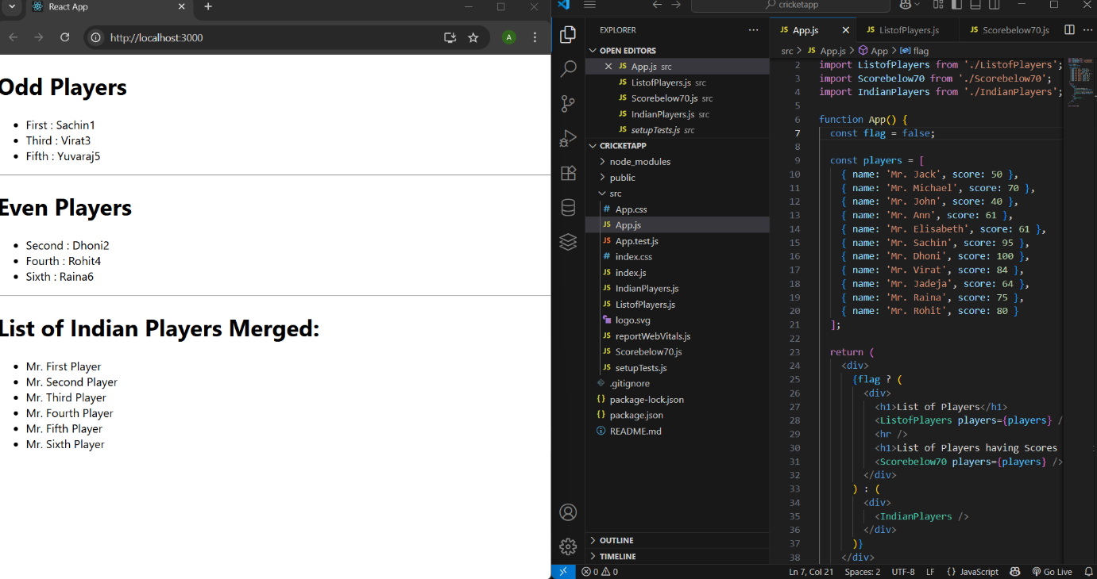
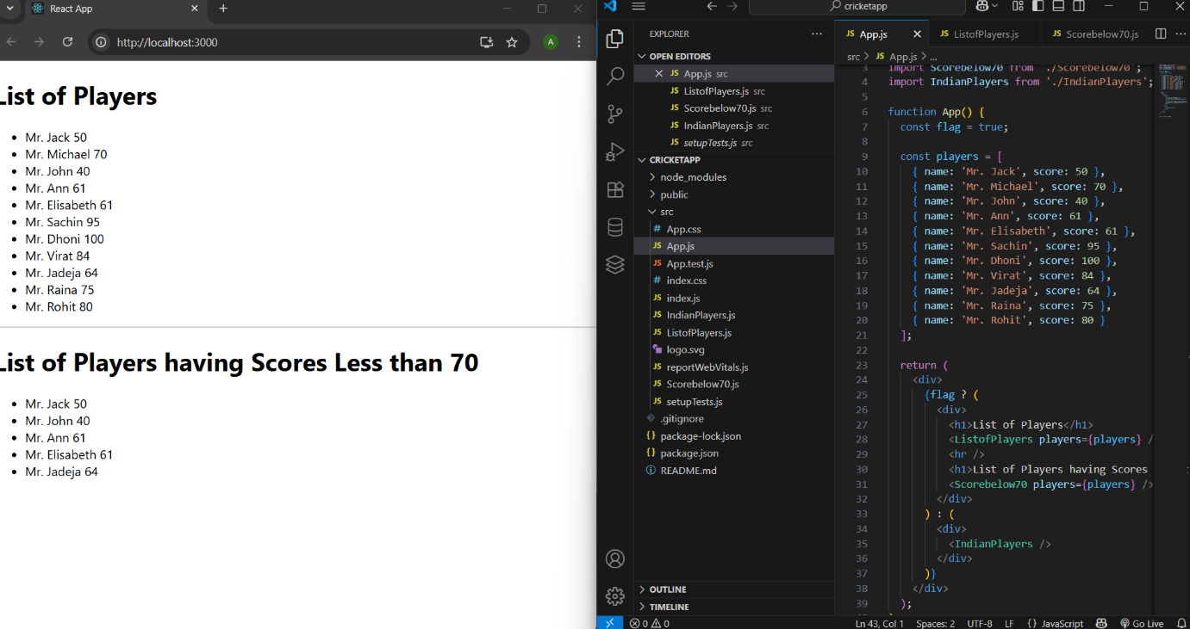
10) OFFICESPACERENTALAPP
App.js
import React from 'react';
import './App.css'; // Optional if you want to use CSS classes

function App() {
const element = "Office Space";
const sr = "https://tse3.mm.bing.net/th/id/OIP.O4coasN0FQbHcDkoCgN3IQHaFS?pid=Api&P=0&h=180"; // sample image

const ItemName = {
Name: "DBS",
Rent: 50000,
Address: "Chennai"
};

// Conditional className array
let colors = [];
if (ItemName.Rent <= 60000) {
colors.push("textRed");
} else {
colors.push("textGreen");
}

const jsxatt = <img src={sr} width="25%" height="25%" alt="Office Space" />;

return (
<div style={{ padding: "20px" }}>
<h1>{element}, at Affordable Range</h1>
{jsxatt}
<h1>Name: {ItemName.Name}</h1>
<h3 className={colors.join(' ')}>Rent: Rs. {ItemName.Rent}</h3>
<h3>Address: {ItemName.Address}</h3>
</div>
);
}
export default App;
reportWebVitals.js
const reportWebVitals = onPerfEntry => {
if (onPerfEntry && onPerfEntry instanceof Function) {
import('web-vitals').then(({ getCLS, getFID, getFCP, getLCP, getTTFB }) => {
getCLS(onPerfEntry);
getFID(onPerfEntry);
getFCP(onPerfEntry);
getLCP(onPerfEntry);
getTTFB(onPerfEntry);
});
}
};

export default reportWebVitals;
setupTests.js
import '@testing-library/jest-dom';

App.test.js
import { render, screen } from '@testing-library/react';
import App from './App';

test('renders learn react link', () => {
render(<App />);
const linkElement = screen.getByText(/learn react/i);
expect(linkElement).toBeInTheDocument();
});

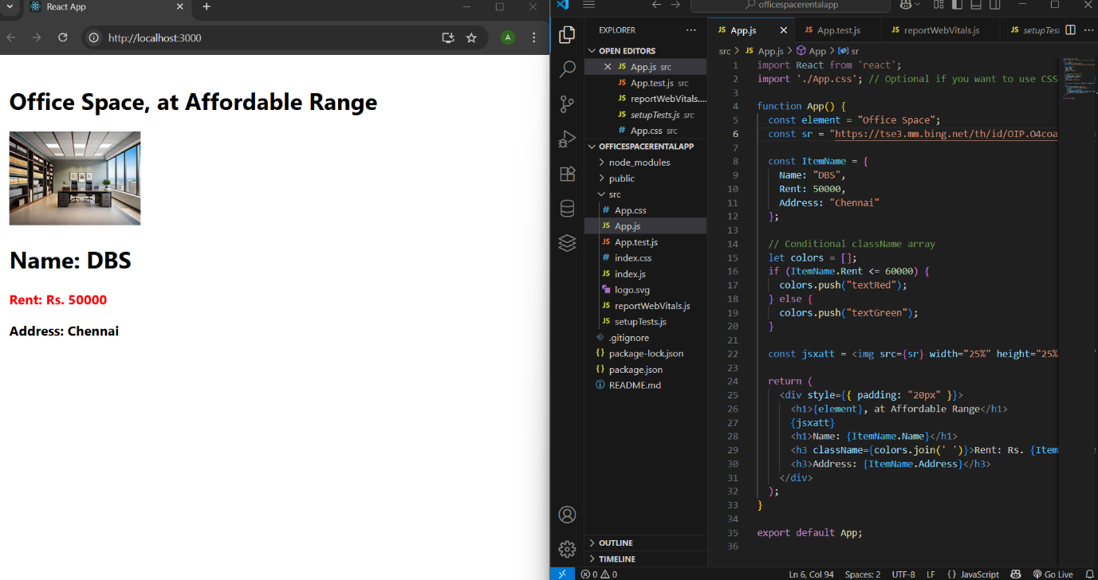
11)EVENTEXAMPLESAPP
CurrencyConverter.js
import React, { useState } from 'react';
const CurrencyConvertor = () => {
const [rupees, setRupees] = useState('');
const [euros, setEuros] = useState(null);

const handleSubmit = (e) => {
e.preventDefault();
const rupeeValue = parseFloat(rupees);
if (!isNaN(rupeeValue)) {
const euroValue = rupeeValue / 90; // Example: 1 Euro = ₹90
setEuros(euroValue.toFixed(2));
} else {
setEuros(null);
}
};

return (
<div style={{ textAlign: 'center', marginTop: '50px' }}>
<h2>Currency Converter - INR to Euro</h2>
<form onSubmit={handleSubmit}>
<input
type="number"
value={rupees}
placeholder="Enter amount in Rupees"
onChange={(e) => setRupees(e.target.value)}
style={{ padding: '8px', fontSize: '16px' }}
/>
<br /><br />
<button type="submit" style={{ padding: '10px 20px' }}>
Convert
</button>
</form>

{euros !== null && (
<h3>{rupees} INR = {euros} EUR</h3>
)}
</div>
);
};
export default CurrencyConvertor;
App.js
import React from 'react';
import EventExample from './EventExample';
import CurrencyConvertor from './CurrencyConvertor';
import './App.css'; // Optional for styling

function App() {
return (
<div className="App">
<h1>React Event Handling & Currency Converter</h1>

{/* Event Handling Demo */}
<EventExample />

<hr style={{ margin: '40px 0' }} />

{/* Currency Converter */}
<CurrencyConvertor />
</div>
);
}

export default App;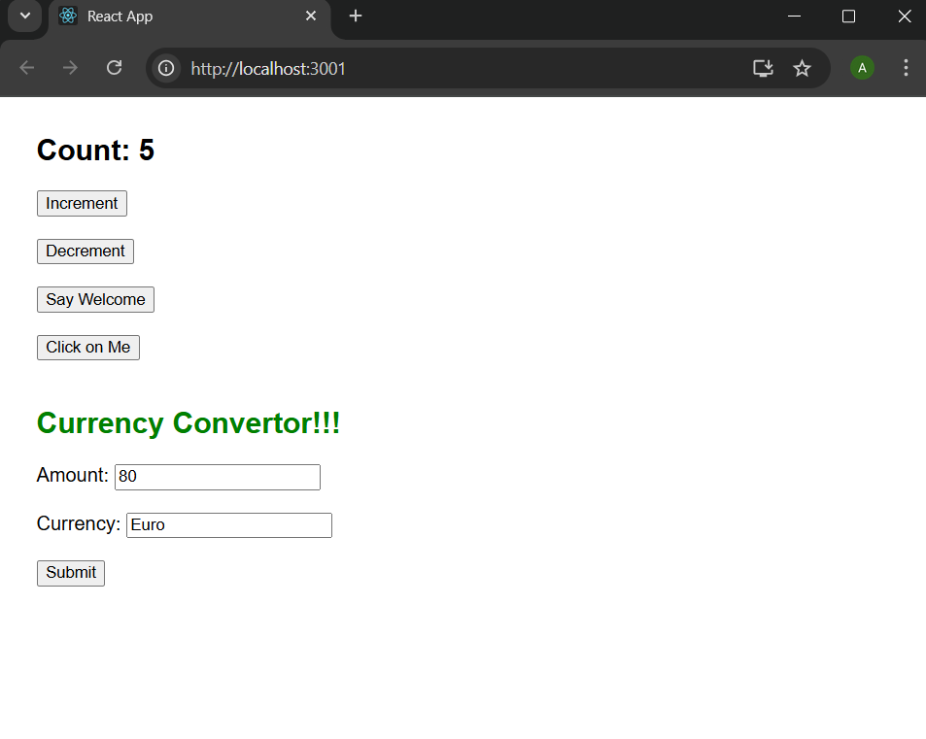

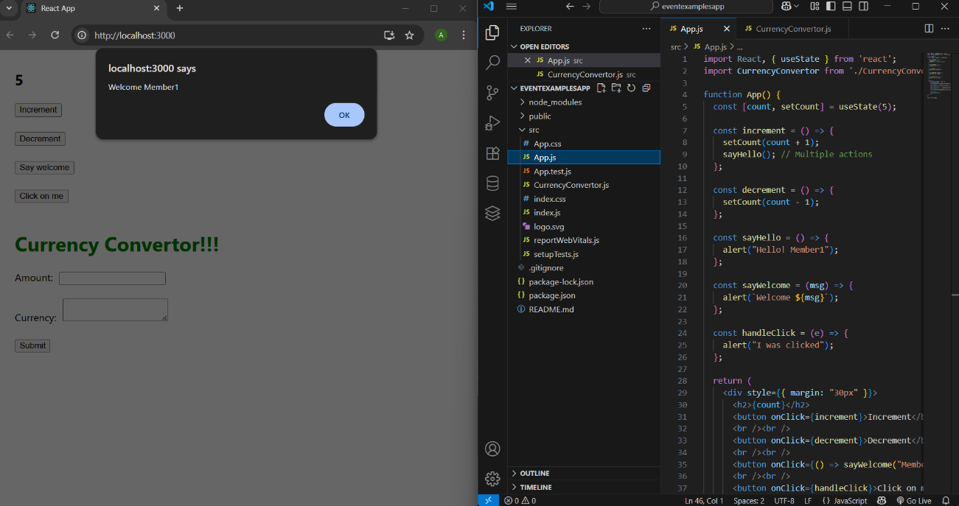
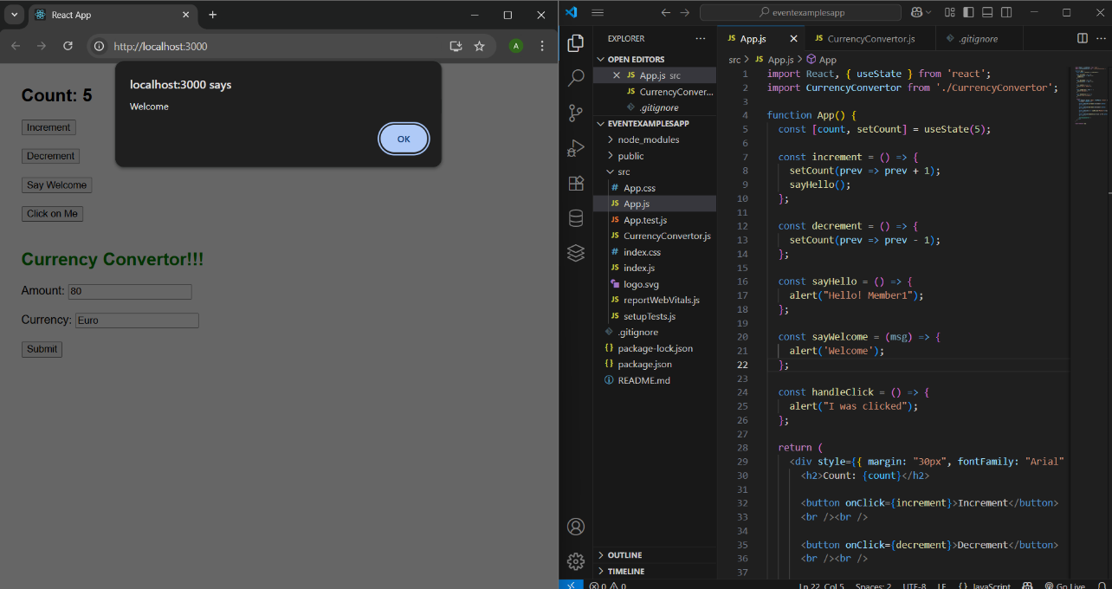
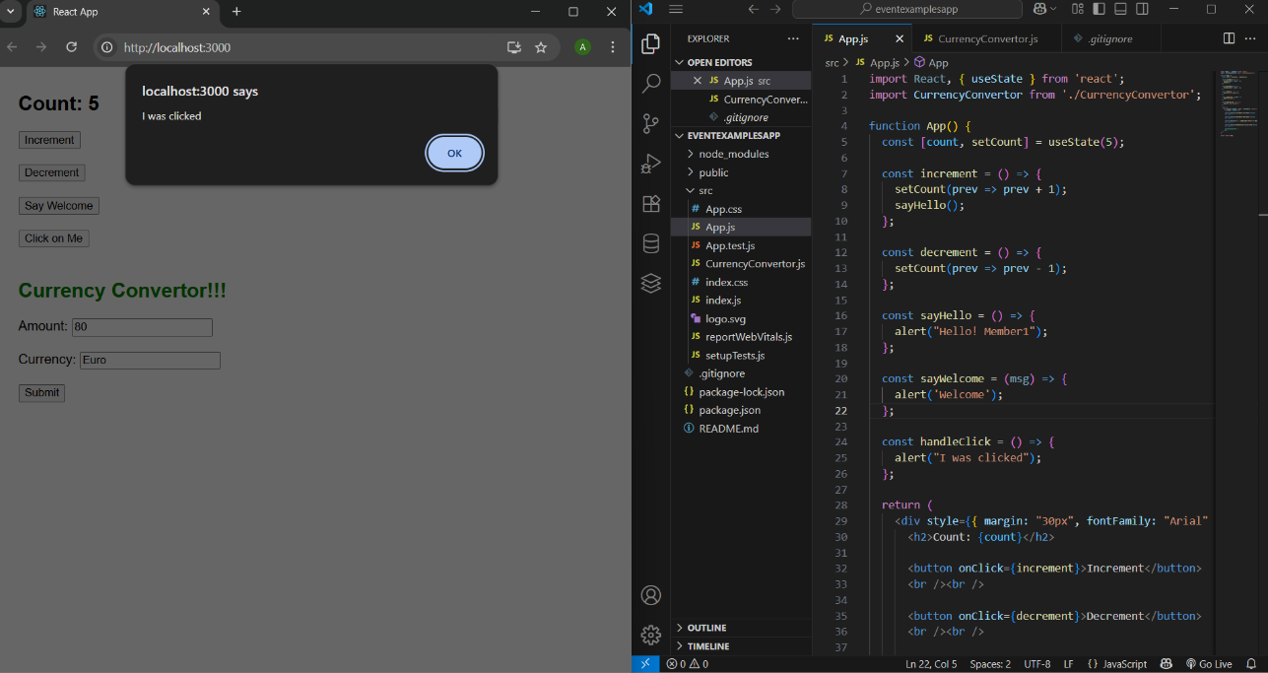
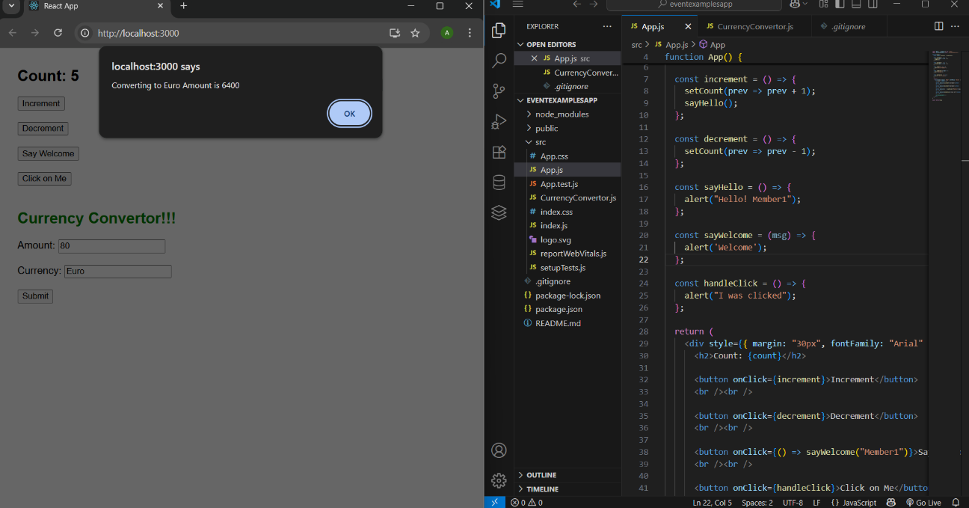

12)TICKETBOOKINGAPP
Greeting.js
function UserGreeting() {
return <h1>Welcome back</h1>;
}

function GuestGreeting() {
return <h1>Please sign up.</h1>;
}

function Greeting(props) {
const isLoggedIn = props.isLoggedIn;
if (isLoggedIn) {
return <UserGreeting />;
}
return <GuestGreeting />;
}
export default Greeting;

LoginButton.js
function LoginButton(props) {
return (
<button onClick={props.onClick}>
Login
</button>
);
}
export default LoginButton;

LogoutButton.js
function LogoutButton(props) {
return (
<button onClick={props.onClick}>
Logout
</button>
);
}
export default LogoutButton;
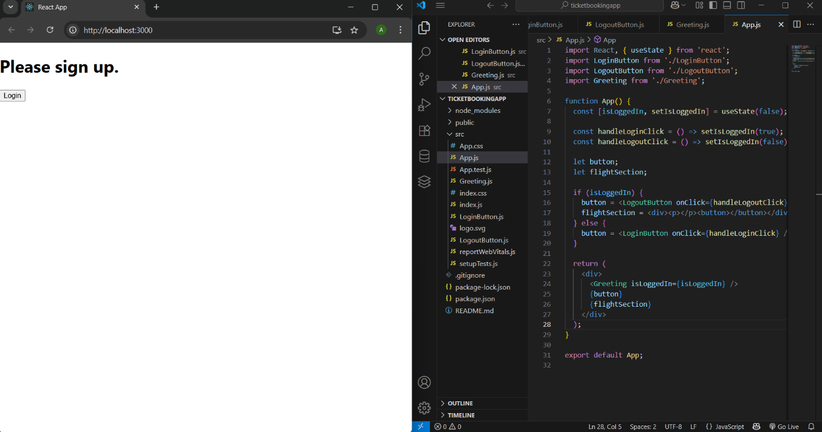
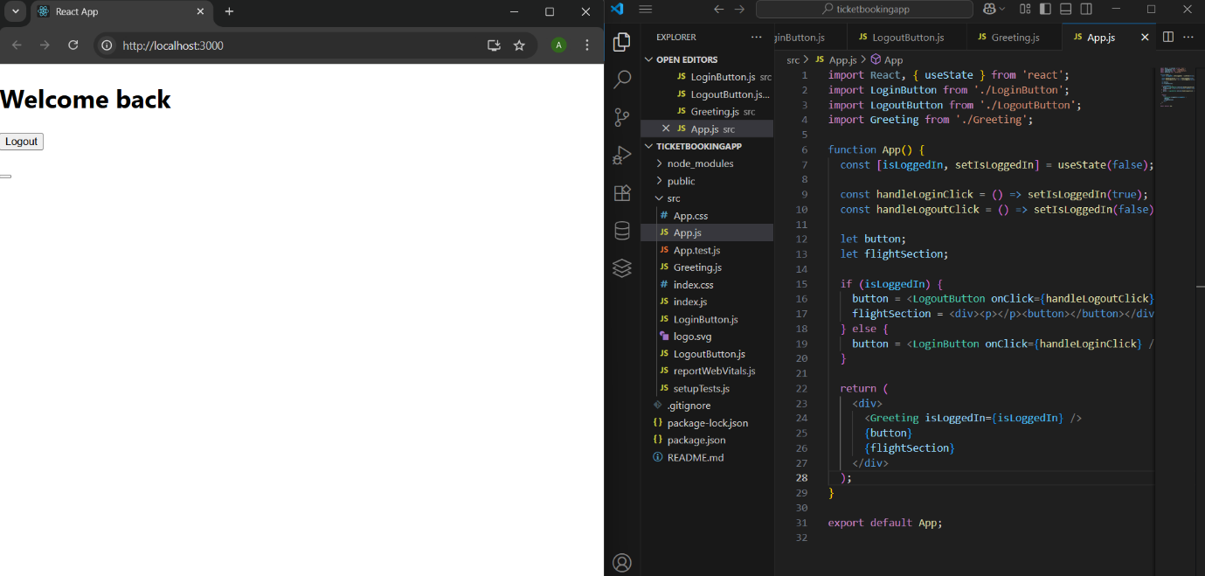
13)BLOGGERAPP
BlogDetails.js
import React from 'react';

const BlogDetails = ({ blogs }) => {
if (!blogs || blogs.length === 0) return <p>No blog entries found</p>;

return (
<div>
{blogs.map((blog, index) => (
<div key={index}>
<h2>{blog.title}</h2>
<h4>{blog.author}</h4>
<p>{blog.desc}</p>
</div>
))}
</div>
);
};

export default BlogDetails;
BookDetails.js
import React from 'react';

const BookDetails = ({ books }) => {
return (
<div className="st2">
<h1>Book Details</h1>
{books.length > 0 ? (
books.map((book) => (
<div key={book.id}>
<h3>{book.bname}</h3>
<h4>{book.price}</h4>
</div>
))
) : (
<p>No books available.</p>
)}
</div>
);
};

export default BookDetails;
CourseDetails.js
import React from 'react';

const CourseDetails = ({ courses }) => {
return (
<div>
{courses?.length ? (
courses.map((course, i) => (
<div key={i}>
<h2>{course.cname}</h2>
<h4>{course.date}</h4>
</div>
))
) : (
<p>No course data found</p>
)}
</div>
);
};
export default CourseDetails;
App.css
.st2,
.v1,
.mystyle1 {
border-left: 5px solid green;
padding: 10px;
min-width: 250px;
}

h1 {
font-size: 24px;
font-weight: bold;
}

h2 {
font-size: 20px;
font-weight: bold;
}

h4 {
margin: 0;
}
Index.css
.st2, .v1, .mystyle1 {
border-left: 3px solid green;
padding: 20px;
width: 30%;
}

div {
font-family: Arial, sans-serif;
}
data.js
export const books = [
{ id: 101, bname: "Master React", price: 670 },
{ id: 102, bname: "Deep Dive into Angular 11", price: 800 },
{ id: 103, bname: "Mongo Essentials", price: 450 },
];
App.js
import React from "react";
import { books } from "./data";
import "./App.css"; // optional for styling

function App() {
const bookdet = (
<ul>
{books.map((book) => (
<div key={book.id}>
<h3>{book.bname}</h3>
<h4>{book.price}</h4>
</div>
))}
</ul>
);

const content = (
<div>
<h2>React Learning</h2>
<h4>Stephen Biz</h4>
<p>Welcome to learning React!</p>

<h2>Installation</h2>
<h4>Schwezdenier</h4>
<p>You can install React from npm.</p>
</div>
);

const coursedet = (
<div>
<h2>Angular</h2>
<h4>4/5/2021</h4>
<h2>React</h2>
<h4>6/3/20201</h4>
</div>
);

return (
<div>
<div style={{ display: "flex", justifyContent: "space-evenly" }}>
<div className="mystyle1">
<h1>Course Details</h1>
{coursedet}
</div>

<div className="st2">
<h1>Book Details</h1>
{bookdet}
</div>

<div className="v1">
<h1>Blog Details</h1>
{content}
</div>
</div>
</div>
);
}
export default App;

